Assigement No 2
Created docker assignment repositories and created 3 diff Branches accordingly 2026-Q1 . 2026-Q2, 2026-Q3 and Created Jenkinsfile inside main branch and added pipeline script inside jenkinsfile. And make Slave Machines and run the job
- Ec2 Instance with 1 Main machine abd 2 slave machine.
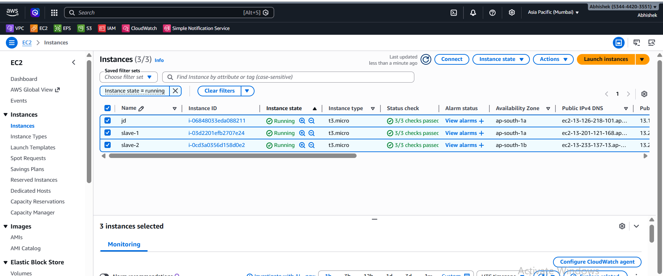
- Git Repo
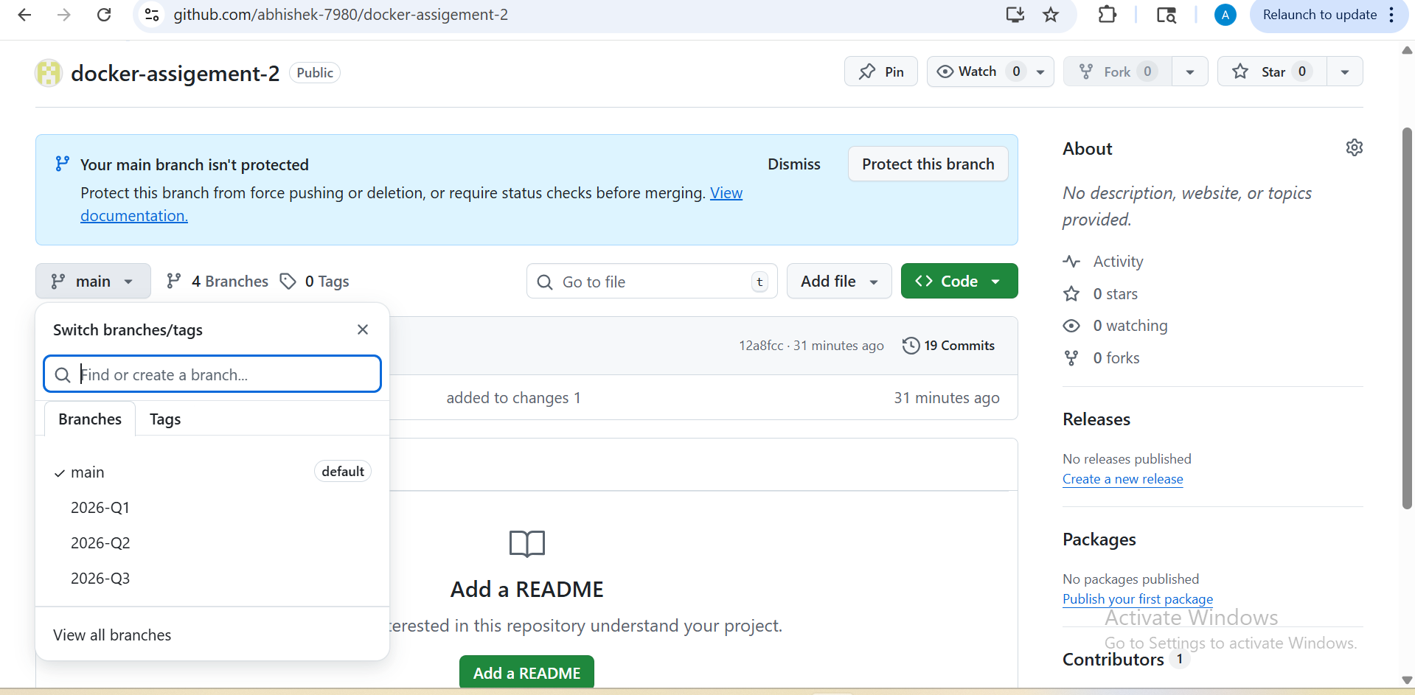

- Jenkinsfile Pipeline script for main Branch
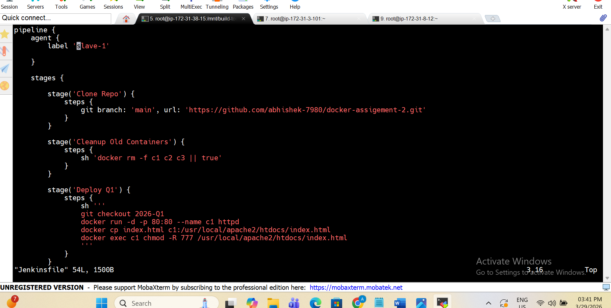
- Here Docker container Created with help of pipline
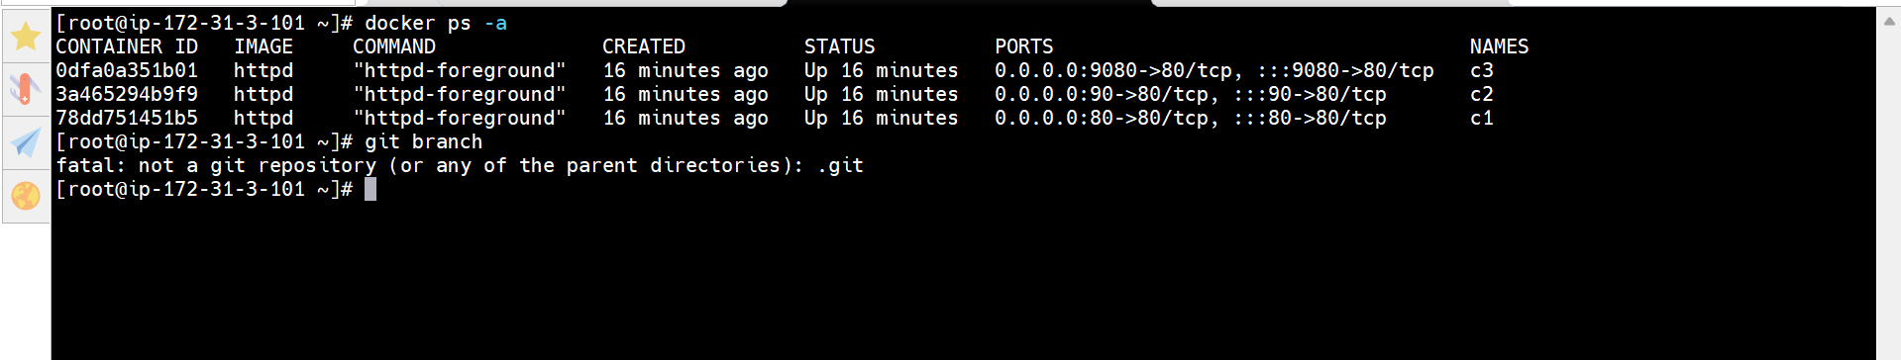
- Her I am doing configuration to execute my job as SCM-git and github repo
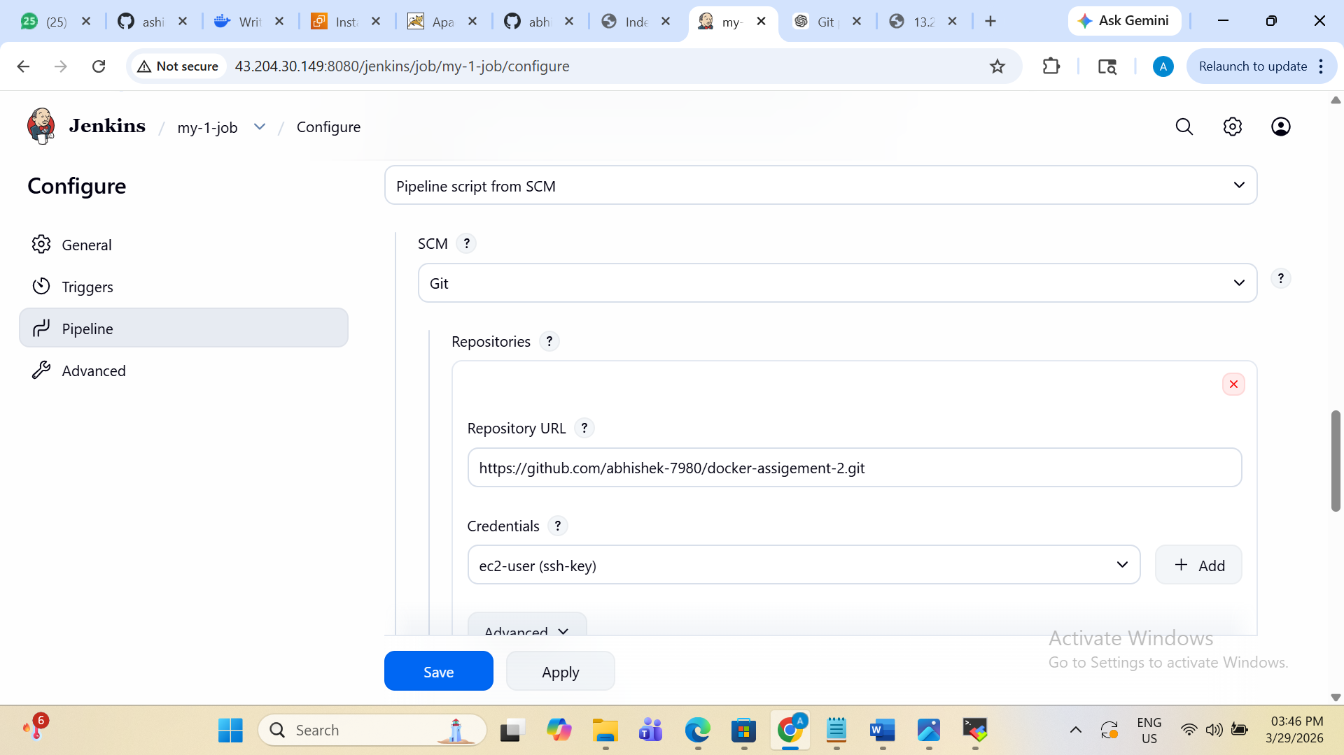
- Here you can see Branch to buid is main branch
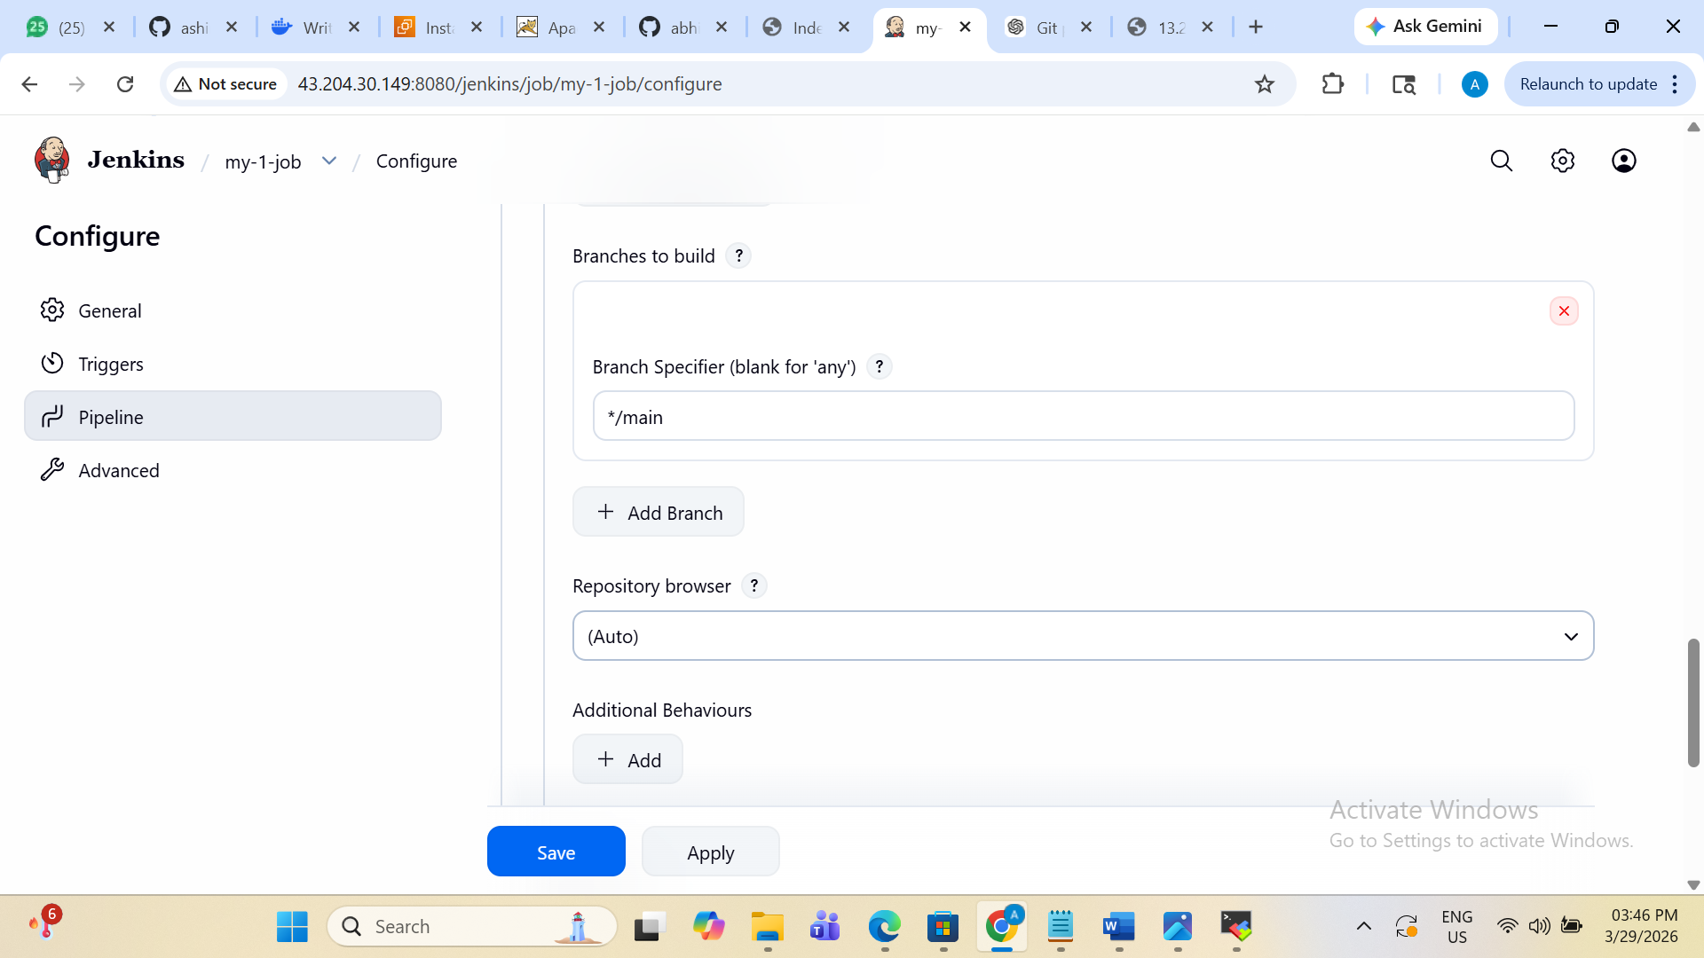

- Slave-1 is Online on Nodes
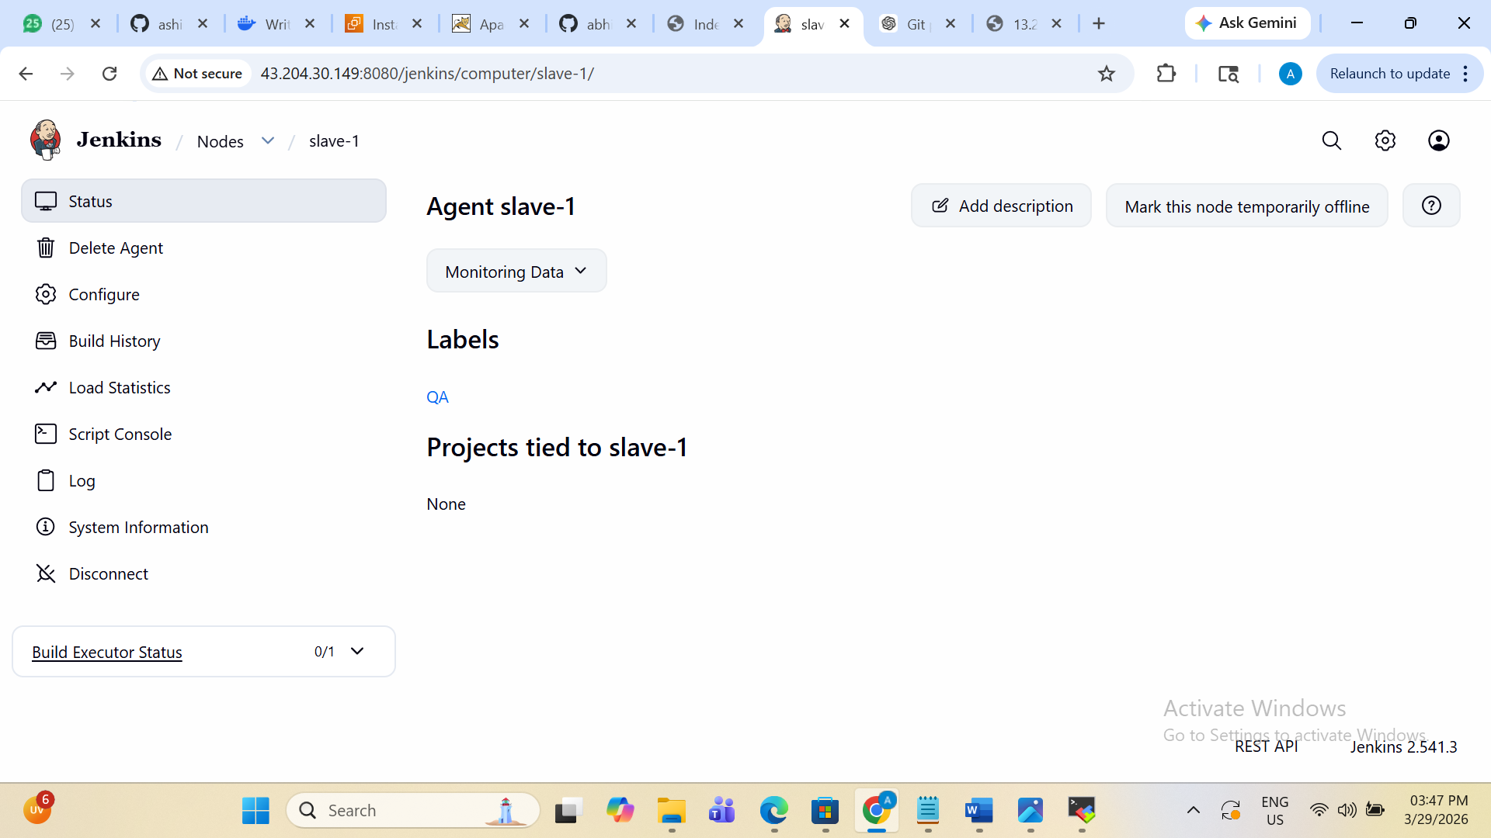

- Slave-1 private IP’s attach to host for connection
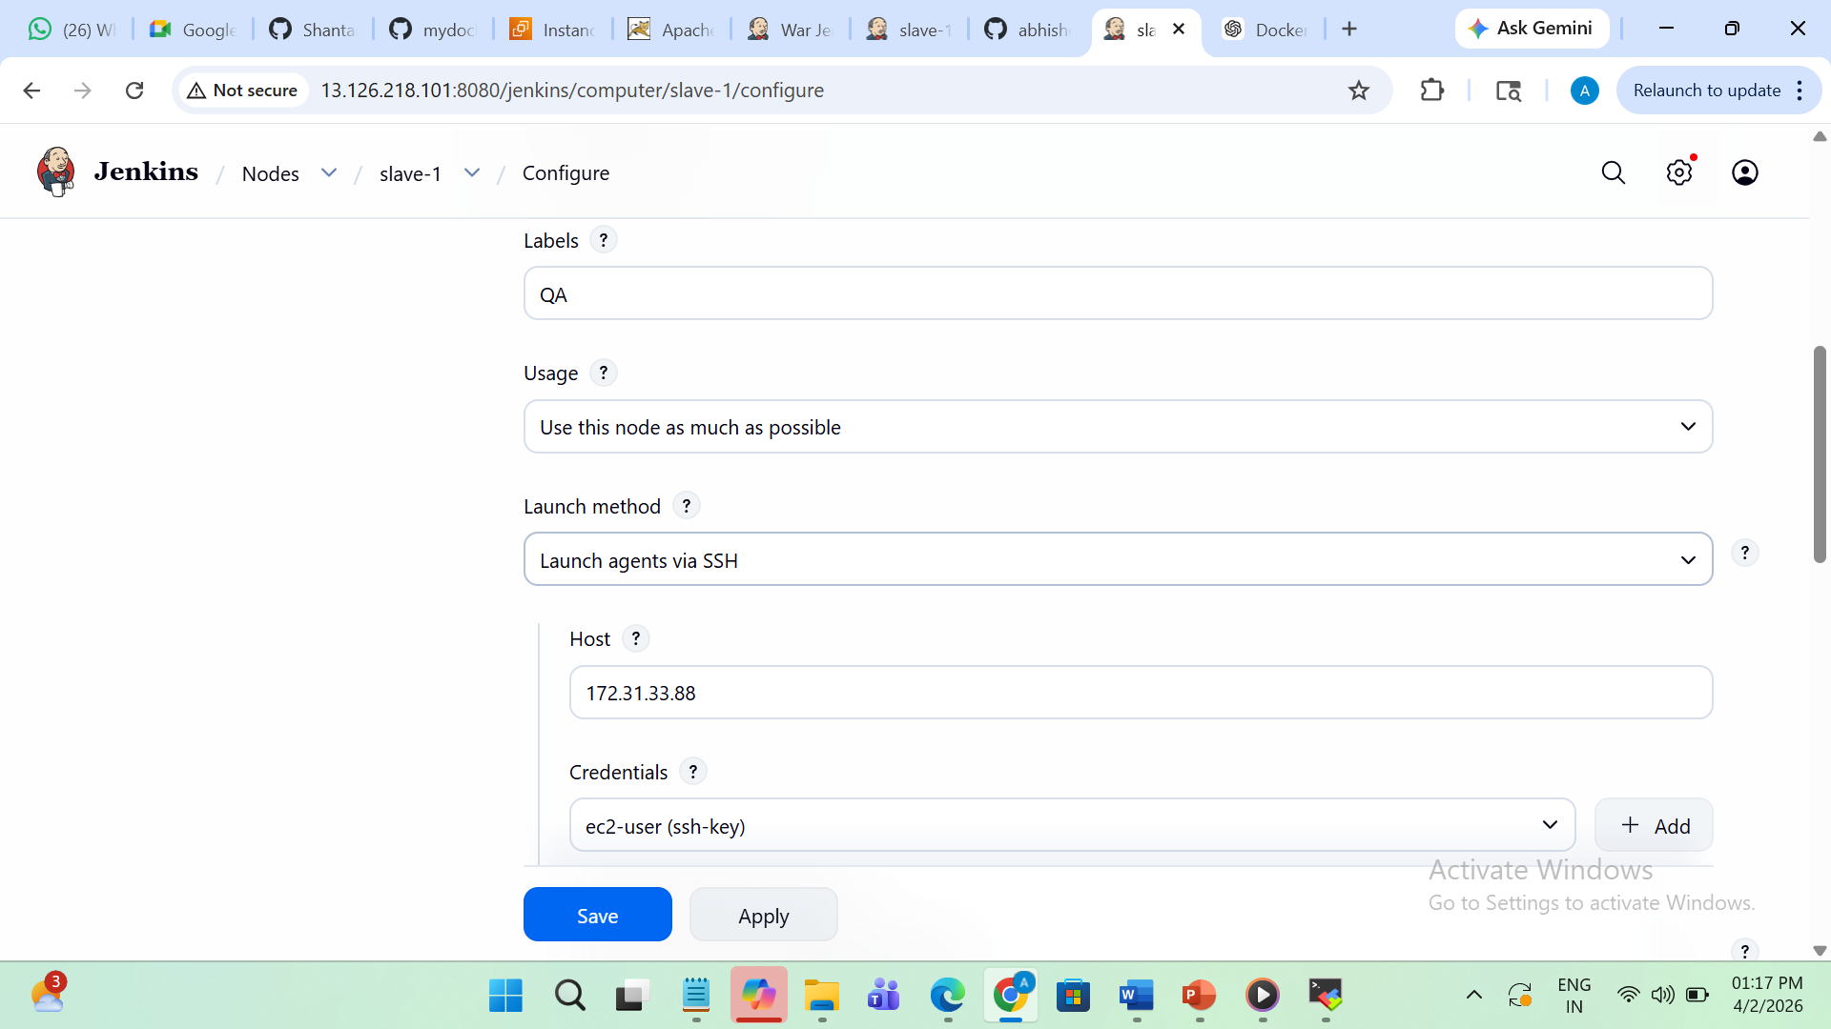
- Slave-2 is Online on Node
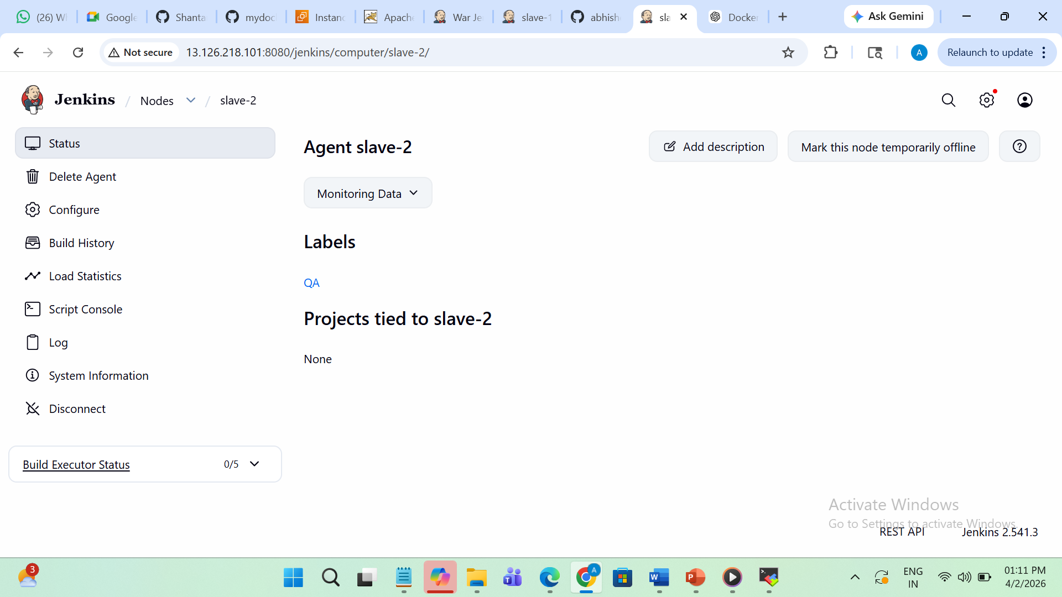

- Slave-2 private IP’s attach to host for connection
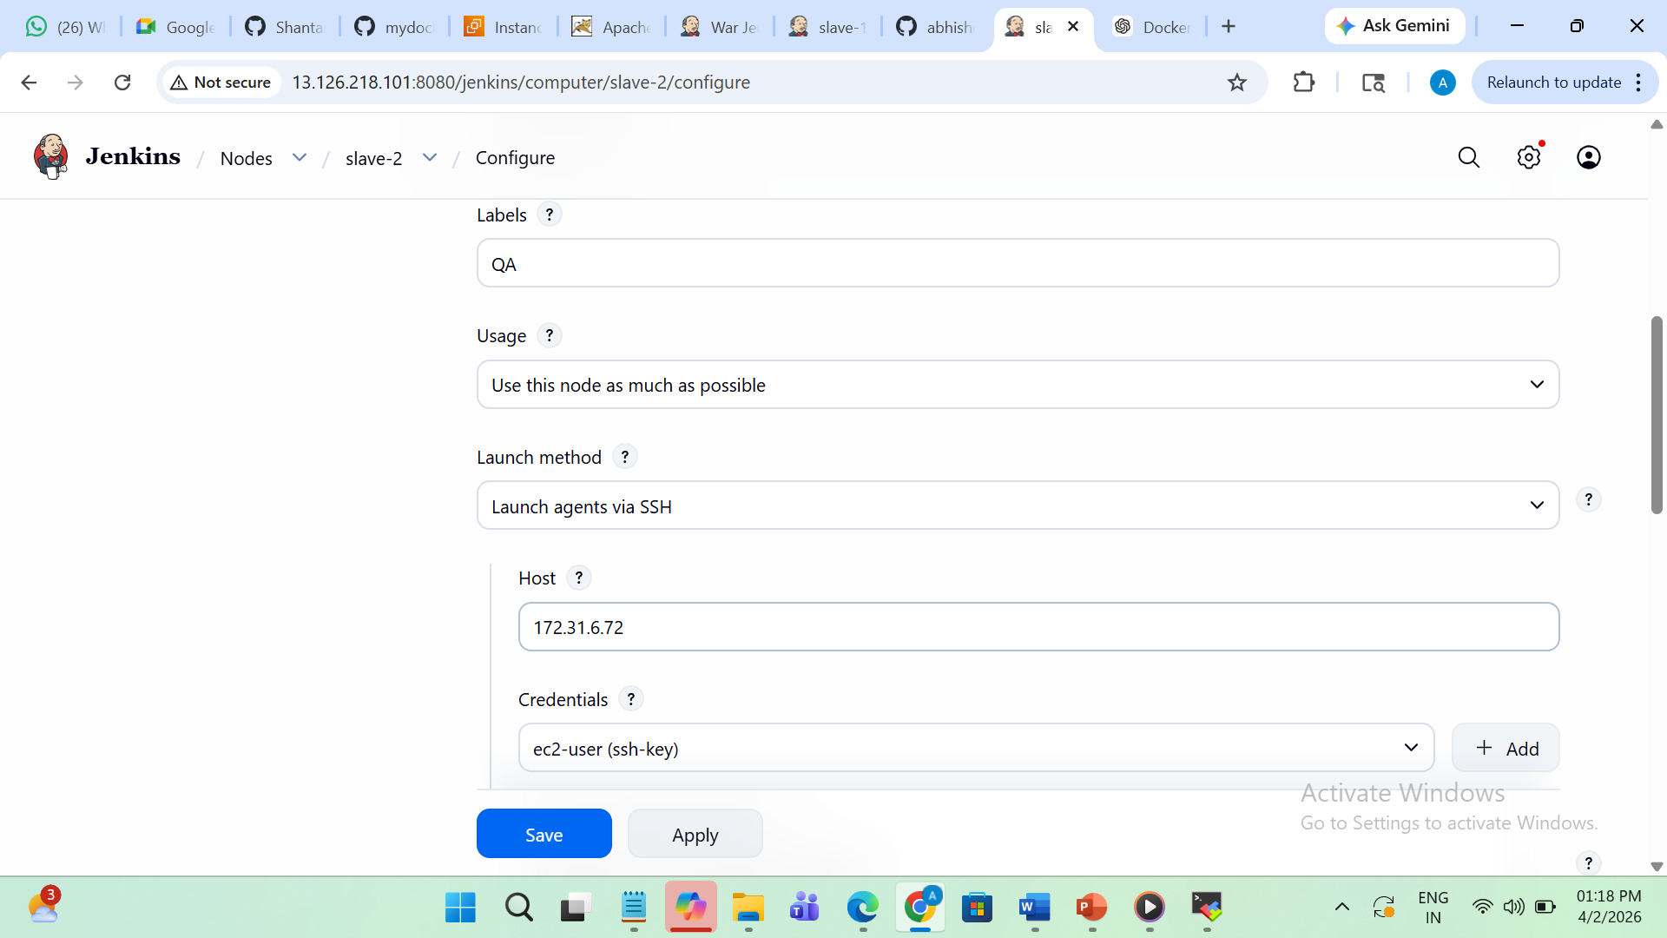
- All node are listed
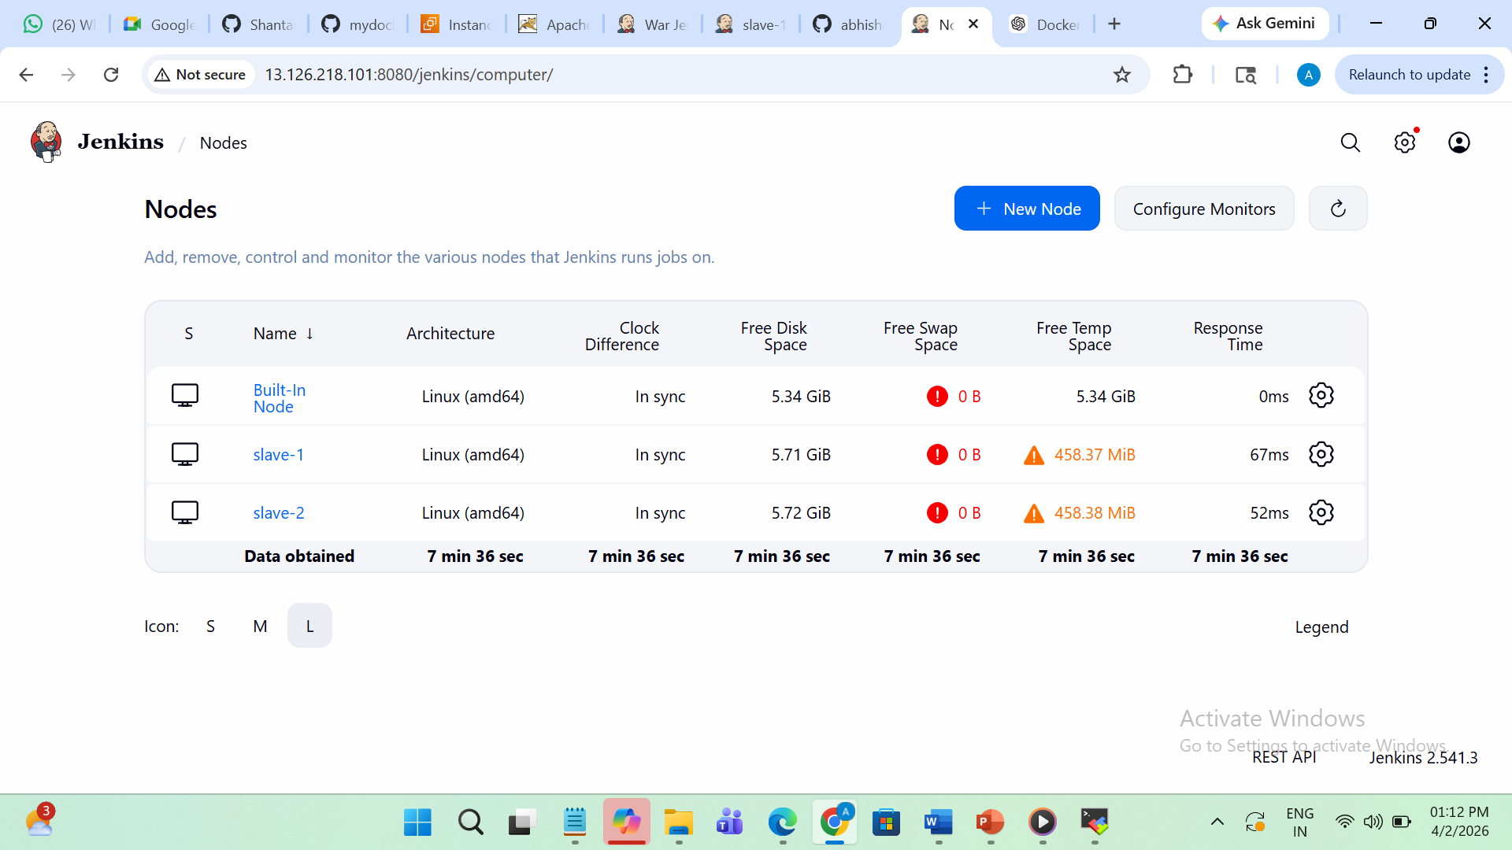

- Here Job run successfully
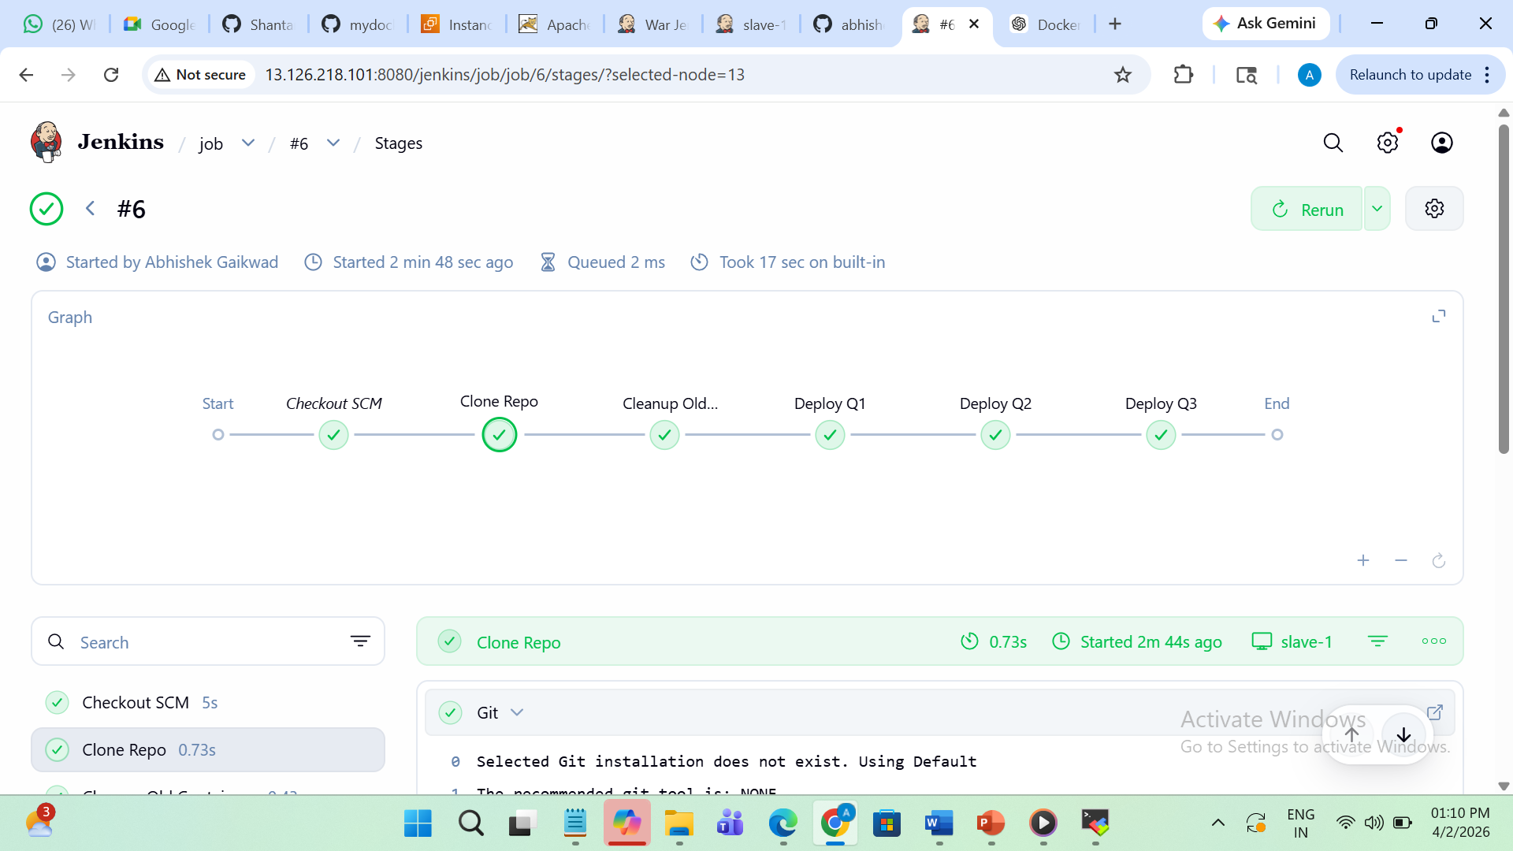
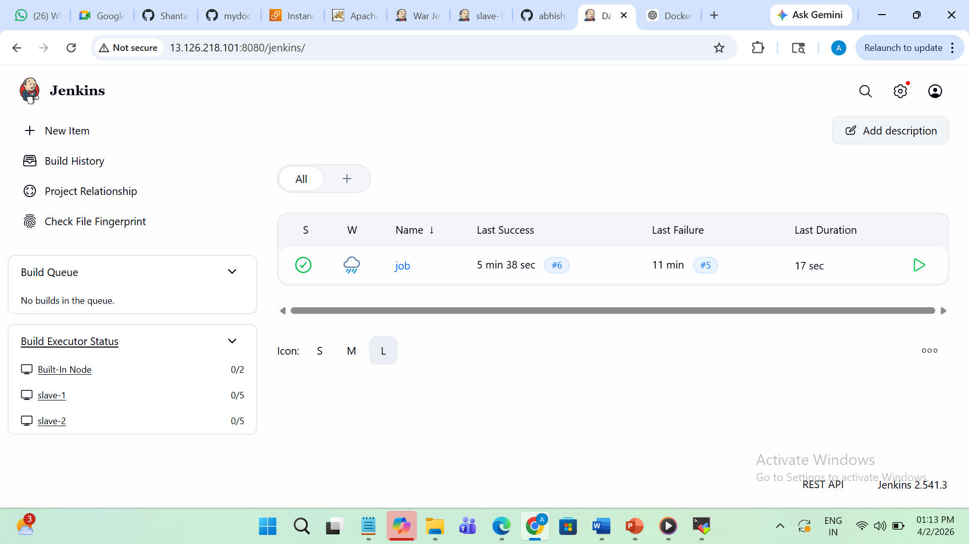

- Here you can see job run successfully on Slave-2
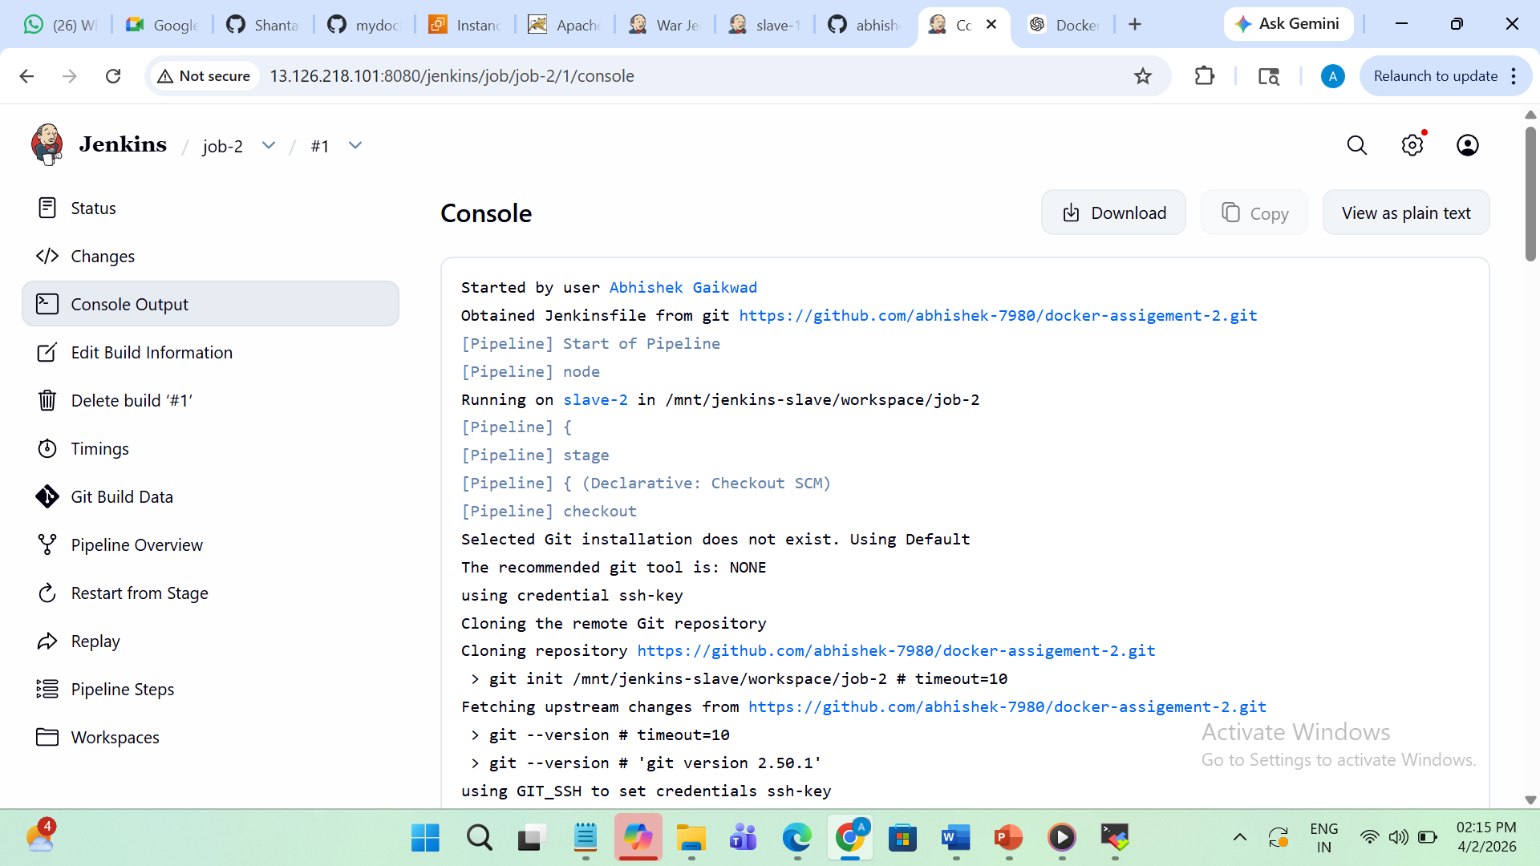
This is and 2026-Q1 output of index.html file at port 80
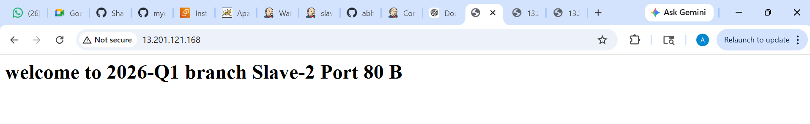
This is and 2026-Q2 output of index.html file at port 90
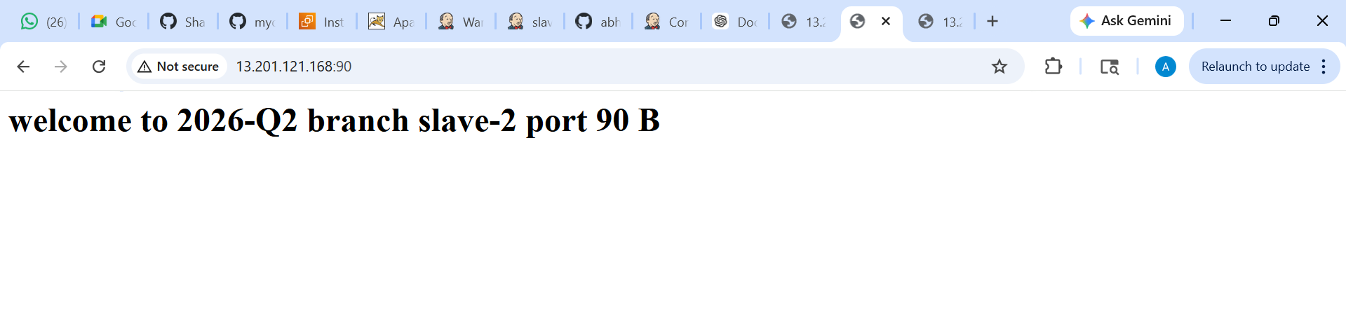
This is and 2026-Q3 output of index.html file at port 9080
